

VARENDRA UNIVERSITY
Department of Electrical and Electronic Engineering
Rajshahi Bypass Road, Chandrima, Paba, Rajshahi-6204

Thesis Proposal

Date: 28 October, 2026

Name of the student:
SL | Name | Student ID
01 | Muntasir Mamun | 232321002
02 | Md. Obaidur Rahman Sifat | 232321022
03 | Jobayer Ahmad | 232321035
Session: Summer 2023

Present Address:

SL | Name | Present Address
01 | Muntasir Mamun | Upar Bhadra, Ghoramara, Boalia, Rajshahi-6204
02 | Md. Obaidur Rahman Sifat | Holidagachi, Charghat, Rajshahi-6271
03 | Jobayer Ahmad | Upar Bhadra, Ghoramara, Boalia, Rajshahi-6204

- Name of the Department: Electrical and Electronic Engineering Programme: EEE
- Name of the Supervisor: Partho Kumer Nonda Designation: Lecturer
- Tentative Title:

Seasonal Grid-Connected Solar System and Hierarchical Droop-Driven Power Management of Combined Electrolyzers for Grid-Frequency Control

- Background and present state of the problem
Hydrogen electrolyzers are increasingly investigated for sustainable hydrogen production and grid-frequency support. Bosak et al. [1] proposed hierarchical droop-based power management for grid-connected hybrid proton exchange membrane electrolyzer (PEME) and alkaline electrolyzer (AE) systems. Falcão and Pinto [2] reviewed PEM electrolyzer modeling approaches, while Tofighi-Milani et al. [3] examined electrolyzer technologies, electrical modeling, and dynamic responses.
Agredano-Torres et al. [4] investigated decentralized power-sharing control for hybrid electrolyzer frequency regulation. Dozein et al. [5], [6] studied virtual inertia, ancillary services, and fast frequency responses. Hossain et al. [7] developed an electrical model of PEM electrolyzers for grid-frequency studies, while Lu et al. [8] investigated dynamic power allocation in renewable-energy-based hybrid hydrogen systems.

1

De Soto et al. [9] developed and validated a photovoltaic performance model, and Albarghot et al. [10] investigated solar-powered PEM electrolyzer modeling. Samani et al. [11] examined primary reserve provision through large-scale electrolyzers. Koundi et al. [12] reviewed PEM electrolyzer modeling and converter control, while Tuinema et al. [13] investigated large-scale electrolyzer models for frequency support.
Dobos [14] presented the PVWatts methodology for photovoltaic power estimation, while the Australian Bureau of Meteorology [15] provides solar irradiance observations. These publications establish the foundations for studying photovoltaic power availability, electrolyzer dynamics, and grid-frequency support.

Justification of the study

Previous research has demonstrated hierarchical droop-based control and dynamic power sharing in hybrid electrolyzer systems [1], [4]. Studies on virtual inertia, fast frequency response, and primary reserve have established the potential of electrolyzers for grid-frequency support [5], [6], [11], [13]. Furthermore, electrolyzer modeling and renewable-energy-based power allocation have been investigated to improve system performance [7], [8], [12]. Solar PV modeling studies provide established methods for evaluating irradiance-dependent power generation [9], [10], [14], while international datasets support solar-resource assessment [15]. However, the selected studies provide limited integrated evaluation of seasonal PV–grid power sharing, hierarchical PEME–AE droop responses, and cumulative hydrogen production. Therefore, the proposed research will investigate these combined aspects under representative summer and winter conditions and eight grid-frequency disturbance scenarios to evaluate dynamic performance, power balance, and hydrogen production.

Objectives with specific aims

The specific objectives of this research are:
- To develop a MATLAB/Simulink model of a seasonal grid-connected solar PV system integrated with proton exchange membrane electrolyzers (PEME) and alkaline electrolyzers (AE), incorporating summer and winter PV–grid power-sharing strategies.
- To implement hierarchical droop-driven power management for coordinated PEME and AE responses under eight grid-frequency disturbance scenarios (−0.2, −0.4, +0.2, and
+0.4 Hz in each season).
- To evaluate the dynamic performance of both electrolyzers by analyzing reference power, voltage, current, hydrogen production, and cumulative hydrogen yield under different seasonal and grid-frequency conditions.

Outline of Methodology/ Experimental Design

The proposed research will be conducted using MATLAB/Simulink to develop and evaluate a seasonal grid-connected solar photovoltaic (PV) system integrated with proton exchange membrane electrolyzers (PEME) and alkaline electrolyzers (AE). The methodology will comprise five sequential stages.

Modeling of system and Integration

The proposed system will be developed in MATLAB/Simulink using a solar PV array, boost converter, utility grid, rectifier, common DC link, two buck converters, and separate PEME and AE units, as illustrated in Fig. 1. The hybrid electrolyzer architecture and hierarchical droop concept will follow Bosak et al. [1], while the PV–grid power-sharing controller will represent the proposed extension. Electrolyzer modeling and converter control will be implemented using established approaches [7], [12].

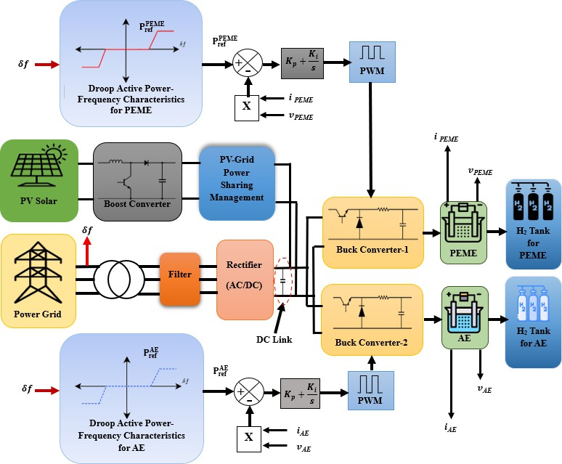

Fig. 1: Proposed seasonal grid-connected solar PV system with hierarchical droop-driven power management of combined electrolyzers.

Seasonal Solar Irradiance and PV–Grid Power Sharing

Representative irradiance values of 950 W/m² and 450 W/m² will be considered for summer and winter, respectively, as controlled simulation assumptions informed by international solar-resource observations [15]. PV output and required capacity will be estimated using irradiance-dependent PV modeling principles [9], [14].
At 950 W/m² and an assumed effective derating factor of 0.90, approximately 210.53 kWp of PV capacity will be required to supply 180 kW per electrolyzer. During summer, each electrolyzer will receive 180 kW from PV and 220 kW from the grid. During the winter grid-only scenario, PV injection will be intentionally disabled and the grid will supply 400 kW per electrolyzer.
The PV output power is estimated as:
PPV = PPV,ᵣₐₜₑd (G / Gₛₜ꜀) ηₑff ……………………… (1)

The required PV array capacity will be determined by:
PPV,ᵣₐₜₑd = (PPV Gₛₜ꜀) / (G ηₑff) ……………... (2)
where Gₛₜ꜀ = 1000 W/m² and the assumed effective derating factor is ηₑff = 0.90. For a required PV contribution of 180 kW per electrolyzer at 950 W/m²:
PPV,ᵣₐₜₑd = (180 × 1000) / (950 × 0.90) = 210.53 kWp ……………… (3)
The combined PV array rating will therefore be:
PPV,ₜₒₜₐₗ = 2(210.53) = 421.06 kWp ……………… (4)

Hierarchical Droop-Driven Power Management

Following Bosak et al. [1], each electrolyzer will have a rated capacity of 750 kW and a nominal operating power of 400 kW. The theoretical additional load-absorption capability will be 350 kW, while the maximum load-reduction capability will be 400 kW per electrolyzer, assuming zero minimum power. The hierarchical controller will prioritize PEME responses during smaller frequency deviations and activate AE support during larger disturbances [1], [4]. Individual buck converter controllers will track the resulting power references, while grid contribution will adjust to the changing demand.

P ^{PEME} = P ^{AE} = 400 kW, R Over =750-400=350 kW,
0 0
R under =400-0 =400 kW.

Grid-Frequency Regulation Simulation

Eight scenarios will be simulated at a nominal frequency of 60 Hz, with disturbances of −0.2, −0.4,
+0.2, and +0.4 Hz applied independently under summer and winter conditions. Irradiance will remain constant within each season to isolate frequency-disturbance effects. The 60 Hz setting will represent a reference-grid test system rather than Bangladesh's 50 Hz national grid.

Performance Evaluation

Each scenario will assess solar irradiance, grid-frequency disturbance, PEME and AE reference powers, final reference powers, voltages, currents, and hydrogen production. Cumulative hydrogen production will be calculated by integrating current-derived production rates. PV power, grid contribution, and DC-link voltage will also be evaluated to examine system power balance and frequency-support performance.

Expected outcomes
The expected outcome(s) of the proposed work should follow the bullet or point manner, which should meet the following outcome template using 2 or 3 specific outcomes (maximum 4):
- A MATLAB/Simulink model integrating seasonal solar PV–grid power sharing with PEME and AE electrolyzers under representative summer and winter operating conditions.
- A hierarchical droop-driven power management strategy demonstrating coordinated electrolyzer responses under eight grid-frequency disturbance scenarios.
- A comparative assessment of PV–grid power sharing, electrolyzer reference powers, voltages, currents, hydrogen production, and cumulative hydrogen yield to evaluate frequency-support performance.

References

- S. Bosak, M. R. I. Sheikh, A. T. Ritu, and J. R. Antora, “Droop-based hierarchical power management of hybrid hydrogen electrolyzers under grid-frequency disturbances,” Eur. J. Electr. Eng. Comput. Sci., vol. 9, no. 5, pp. 59–65, Oct. 2025, doi: 10.24018/ejece.2025.9.5.753.
- D. S. Falcão and A. M. F. R. Pinto, “A review on PEM electrolyzer modelling: Guidelines for beginners,” J. Clean. Prod., vol. 261, Art. no. 121184, Jul. 2020, doi: 10.1016/j.jclepro.2020.121184.
- M. Tofighi-Milani, S. Fattaheian-Dehkordi, and M. Lehtonen, “Electrolysers: A review on trends, electrical modeling, and their dynamic responses,” IEEE Access, vol. 13, 2025, doi: 10.1109/ACCESS.2025.3546546.
- M. Agredano-Torres, M. Zhang, L. Söder, and Q. Xu, “Decentralized dynamic power sharing control for frequency regulation using hybrid hydrogen electrolyzer systems,” IEEE Trans. Sustain. Energy, vol. 15, no. 3, pp. 1847–1858, Jul. 2024, doi: 10.1109/TSTE.2024.3381491.
- M. Ghazavi Dozein, A. M. De Corato, and P. Mancarella, “Virtual inertia response and frequency control ancillary services from hydrogen electrolyzers,” IEEE Trans. Power Syst., vol. 38, no. 3, pp. 2447–2459, May 2023.
- M. Ghazavi Dozein, A. Jalali, and P. Mancarella, “Fast frequency response from utility-scale hydrogen electrolyzers,” IEEE Trans. Sustain. Energy, vol. 12, no. 3, pp. 1707–1717, Jul. 2021.

- M. B. Hossain, M. R. Islam, K. M. Muttaqi, D. Sutanto, and A. P. Agalgaonkar, “Dynamic electrical circuit modeling of a proton exchange membrane electrolyzer for frequency stability, resiliency, and sensitivity analysis in a power grid,” IEEE Trans. Ind. Appl., vol. 59, no. 6, pp. 7271–7281, Nov.–Dec. 2023, doi: 10.1109/TIA.2023.3297985.
- Y. Lu, G. Yang, X. Li, J. Liu, T. Yang, and J. Liu, “Dynamic power allocation for the new energy hybrid hydrogen production system based on WOA-VMD: Improving fluctuation balance and optimizing control strategy,” Int. J. Hydrogen Energy, vol. 94, pp. 580–599, Dec. 2024.
- W. De Soto, S. A. Klein, and W. A. Beckman, “Improvement and validation of a model for photovoltaic array performance,” Sol. Energy, vol. 80, no. 1, pp. 78–88, Jan. 2006, doi: 10.1016/j.solener.2005.06.010.
- M. Albarghot, M. Sasi, and L. Rolland, “MATLAB/Simulink modeling and experimental results of a PEM electrolyzer powered by a solar panel,” J. Energy Power Eng., vol. 10, no. 12, pp. 779–785, Dec. 2016, doi: 10.17265/1934-8975/2016.12.009.
- A. E. Samani, A. D’Amicis, J. D. M. De Kooning, D. Bozalakov, P. Silva, and L. Vandevelde, “Grid balancing with a large-scale electrolyser providing primary reserve,” IET Renew. Power Gener., vol. 14, no. 16, pp. 3070–3078, Dec. 2020, doi: 10.1049/iet-rpg.2020.0453.
- M. Koundi et al., “Investigation of hydrogen production system-based PEM EL: PEM EL modeling, DC/DC power converter, and controller design approaches,” Clean Technol., vol. 5, no. 2,
pp. 531–568, Apr. 2023, doi: 10.3390/cleantechnol5020028.
- B. W. Tuinema et al., “Modelling of large-sized electrolysers for real-time simulation and study of the possibility of frequency support by electrolysers,” IET Gener. Transm. Distrib., vol. 14, no. 10, pp. 1985–1992, May 2020, doi: 10.1049/iet-gtd.2019.1364.
- A. P. Dobos, “PVWatts version 5 manual,” National Renewable Energy Laboratory, Golden, CO, USA, Tech. Rep. NREL/TP-6A20-62641, 2014, doi: 10.2172/1158421.
- Australian Bureau of Meteorology, “Himawari-8/9 surface global solar irradiance,” Australian Government. [Online]. Available: https://www.bom.gov.au/climate/how/newproducts/himawari-irradiance.shtml. Accessed: Oct. 16, 2026.

